VESSEL : | PORT : | DATE :
TYPE OF ENGINE: | MAIN /AUX ENG. NO.: | DATE LAST DEFLECTION:
DRAFT FORD: | DRAFT AFT: | TRIM :
- Start with crank at D.B.C.
- Move crank to position “A” and fit gauge between the webs, set dial to zero.
- Continue turning the engine in direction shown (ahead direction) and read gauge at position “B”, “C”, “D” and “E” of crankpin , without stopping movement of crankshaft.
- Opening of webs to be recorded as +.
- Closing of webs to be recorded as -.
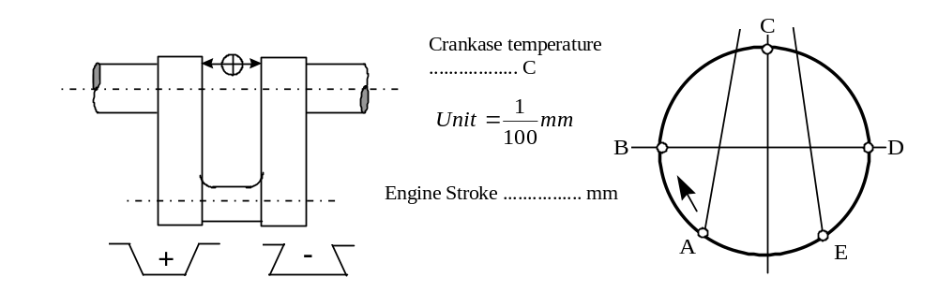

CRANKPIN
POSITION | 1 | 2 | 3 | 4 | 5 |  | 6 | 7 | 8 | 9 | 10
A
B
C
D
E
MAX
DEFLECTION
PREPARED 2ND ENGINEER : |  |  |  |  |  | VERIFIED BY CHIEF ENGINEER :

